Satire
Briefly describe the satirical subject / issue in each of the following cartoons. How does the use of each specified technique assist audience understanding concerning the subject / issue? What is the audience being persuaded to do about the subject / issue?

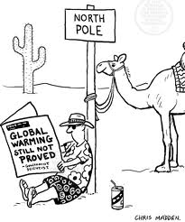
Hyperbole:

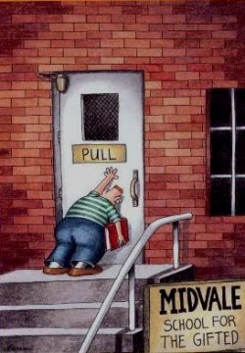
Irony: Understatement:

Juxtaposition:

Oxymoron:

Parody:

